UBI Test: Technical ArtisT

Test Objectives
- Your knowledge and skills in artistic application of technical skills.
  - I will be judging your shaders from an artistic and technical perspective.
- Your ability to solve problems by using your existing skills or to learn new skills

Test rules
- Any related document should be in English.
- You can use any tool you want to make this.
- Please send your test submission to han.han@ubisoft.com.

What you should submit

- Project files for your shaders, images of your node network (if you use a node based shader system like Unreal or Unity’s Shaderforge),
- At least 3 renders of your shader on multiple shapes, and 1 video turn around of the object.
- Please provide an explanation note for your shader and how it is intended to work.

Test content 测试内容
- Build 2 versions of one shader with the following requirements:
  - The shader should show growth of underwater grunge/moss over an object that has been underwater for a long time.

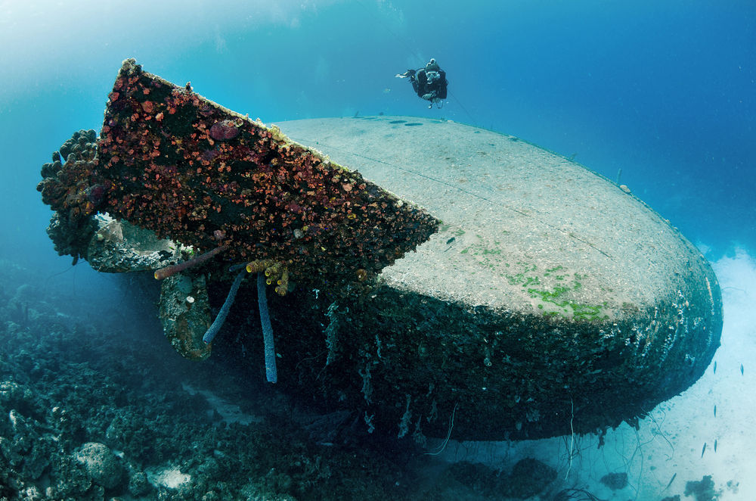
    - Both MUST be PBR compliant
      - Any version of PBR is okay. (just use whichever tool you are most comfortable with)
    - Must have a working texture set (albedo, normals, spec, gloss, whatever you need to make it look good)
      - Do not worry about texture budgets here
      - The PBR textures are required for both, however, if your AAA shader uses more textures than the lower end shader that’s okay.
      - I am not judging you for your textures. You can make them yourself or you can use a free website.

  - Version 1: AAA standards.
    - I want to see the fanciest shader you can imagine. No budgets to worry about here. Make “the benchmark” that the game will be held to.
      - Lots of controls and settings to play with.
    - Keep artists in mind. How will they use this shader?
  - Version 2: Simple:
    - You have very little budget to work with. This time you must balance the budgets and the visuals. Don’t make it ugly but don’t make it expensive.

